**Problem with getline() after cin >>.**

The *getline()* function in C++ is used to read a string or a line from the input stream. The *getline()* function does not ignore leading white space characters. So special care should be taken care of about using *getline()* after *cin* because *cin* ignores white space characters and leaves it in the stream as garbage.

*Program 1:*

Below is the C++ program to illustrate the same:

|  |
| --- |
| // C++ program for the above problem  #include <iostream>  using namespace std;    // Driver Code  int main()  {      int fav_no;      string name;        cout << "Type your favorite number: ";        // The cin statement uses the      // fav_no and leaves the \n      // in the stream as garbage      cin >> fav_no;        cout << "Type your name : ";        // getline() reads \n      // and finish reading      getline(cin, name);        // In output only fav_no      // will be displayed not      // name      cout << name           << ", your favourite number is : "           << fav_no;        return 0;  } |

Output:

[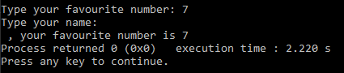](https://media.geeksforgeeks.org/wp-content/cdn-uploads/20210224105956/Screenshot-798.png)

Explanation:

The solution to solve the above problem is to use something which extracts all white space characters after *cin*. [std::ws](https://www.geeksforgeeks.org/manipulators-in-c-with-examples/) in C++ to do the same thing. This is actually used with the “>>” operator on input streams.

*Program 2:*

Below is the C++ program to illustrate the solution for the above problem:

|  |
| --- |
| // C++ program for the above solution  #include <iostream>  using namespace std;    // Driver Code  int main()  {      int fav_no;      string name;      cout << "Type your favourite number: ";      cin >> fav_no;        cout << "Type your name: ";        // Usage of std::ws will extract      // all  the whitespace character      getline(cin >> ws, name);        cout << name           << ", your favourite number is : "           << fav_no;      return 0;  } |

Output:

[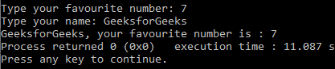](https://media.geeksforgeeks.org/wp-content/cdn-uploads/20210224105957/Screenshot-797.png)